How to Sign-up and Volunteer for a swim meet
First log-in to the website (www.novatoriptide.org). Select the find the meet you are attending:
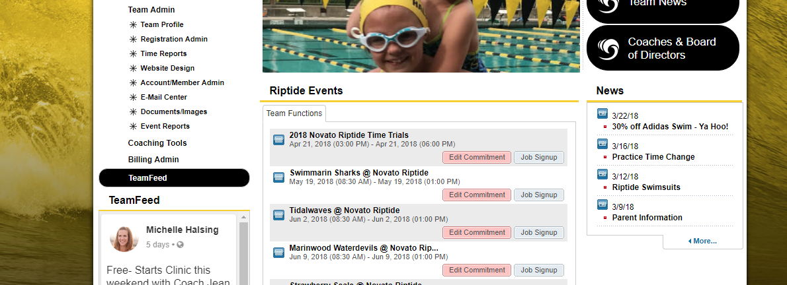
Click on the Job Signup button
You should then see this page. It will contain the jobs available for the meet.
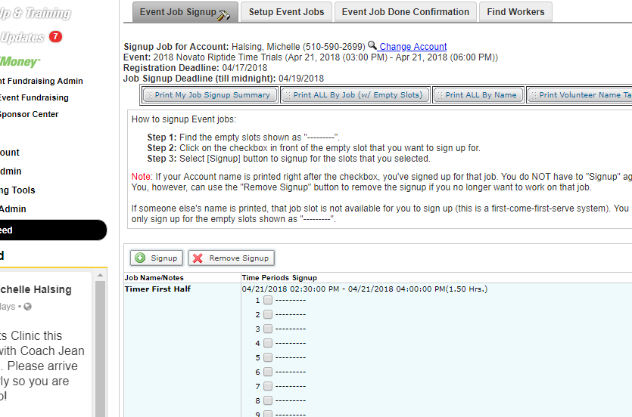
Click on the box and select the signup button:
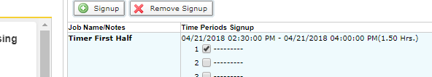
Once you do that it should look like this and you are good to go:
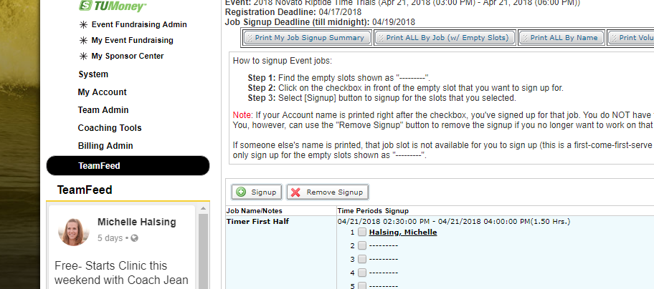
After this you have successfully signed up to volunteer. You can find a detailed descriptions of jobs online. https://www.teamunify.com/SubTabGeneric.jsp?team=recmsnr&_stabid_=73780
Most of the jobs anyone can do. Stroke & Turn, Starters, and judges need extra training. Everything else is first come first serve. With that being said please do not take morning shifts if your swimmer swims breaststroke or butterfly. You will be at the meet all day so let’s reserve these spots for the families that can leave after backstroke.
We have a shopper this year taking care of all the shopping. We still need some behind the scenes volunteers, the person is responsible for this job for every home meet. If you agree to this job you are on the hook all 5 home meets (includes time trials).
We need someone to grill and cut up chicken breasts (we buy the meat), make Jell-O cups (80/meet), bake potatoes (~25-30/meet), and Snack Bar set-up (early shift day of meet). We will have more but these I need filled ASAP.

